The formation of a CA²⁺-dependent complex of C-reactive protein and very low density lipoprotein causes the biphasic transmittance waveform
Michael Nesheim¹, John Samis², John Walker¹, Timothy Fischer^{3,5}, Liliana Tejidor³, Greg Jones³, Wim Houdijk³, Alan Giles³, Lev Becker¹, Marlys Koschinsky¹, Richard Wenstone⁴, Colin Downey⁴, Cheng Hock Toh⁴
¹ Department of Biochemistry, Queen's University, Kingston, Ontario, Canada, K7L 3N6
² Department of Pathology, Queen’s University, Kingston, Ontario, Canada, K7L 3N6
³ Organon Teknika Corporation, Durham, NC 27712, USA
⁴ Department of Haematology, Royal Liverpool University Hospital, Liverpool, L7 8XP, UK
⁵ Current address, Ventana Medical Systems, Tucson, Arizona, USA
Michael Nesheim
1 Sample Road
Sampletown
CA 12345
USA
Tel: (914) 123 4567
Fax: (914) 123 4568
Email: nesheim@medecine.unige.ch
Clinical background:
The “biphasic transmittance waveform” (BTW) refers to a time-dependent decrease in light transmittance that often occurs prior to clotting when performing the activated partial thromboplastin time (aPTT) assay with plasmas of critically ill patients on the MDA® coagulation analyzer [1]. Early observations showed an association of the BTW with disseminated intravascular coagulation (DIC) and clinical outcome. (See Table 1) The magnitude of the BTW was assessed against in-patient mortality. A total of 346 patients were found to have a BTW on admission to the ITU with a mortality rate of 44%, as compared with 26% for those with normal waveforms. A stepwise increase in the likelihood of mortality was directly correlated with the degree of drop in light transmittance observed on admission (see Figure 1). The mortality fraction was 0.3 in those with normal waveforms versus 0.6 when the light transmittance decreased by 30%.

Table Title: CRP by indicators of social class in VERA:
 |  |  |  | p*
Education (years) | ≤9 | 10-12 | ≥13
CRP (mg/L) crude | 1.20 | 1.07 | 0.98 | 0.0001
adjusted§ | 1.14 | 1.13 | 1.10 | 0.56
Occupation# (status) | a | b | c
 | 1.13 | 1.13 | 1.04 | 0.04
 | 1.15 | 1.17 | 1.08 | 0.12
Household income (DM) | ≤2000 | 2-3000 | ≥3000
 | 1.19 | 1.11 | 1.06 | 0.002
 | 1.20 | 1.09 | 1.10 | 0.02
Table Footnote: #a=worker and farmers, b=clerks and civil cervants, c=employers, freelancer
*p for difference between upper and bottom category
§ adjusted for age, sex, smoking status, BMI, physical activity, and HDL-cholesterol

Figure Title: Figure 1
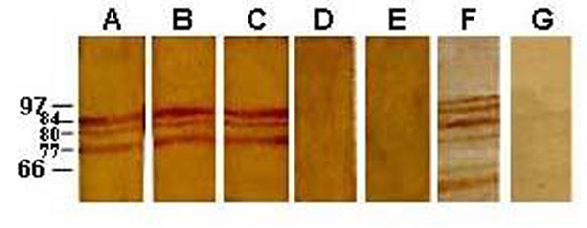
Figure Caption: Immunoblot of monoclonal antibodies against IROMPs of A. baumannii ATCC 19606 Immunoblot of Monoclonal antibodies with OMP of A. baumannii grown in CDM-Fe medium.
Molecular Weight markers were marked in kDa. Lane A. 2G_{g}ABIR; B. 3D₅ABIR C. 1D₁₁ABIR D. 5D₆ABIR E. 1F₇ABIR F. +ve control G. -ve control

Conclusion:
Detection and analysis of an atypical biphasic aPTT clot waveform is a strong and early predictor of clinical outcome in patients admitted to the ITU. The formation of lipoprotein-complexed C-reactive protein (LC-CRP) is the biochemical basis of the biphasic waveform seen in these patients.

[1]. C Downey, R Kazmi, CH Toh: Early identification and prognostic implications in disseminated intravascular coagulation through transmittance waveform analysis. Thromb Haemost 1998, 80: 65-69

Conflict of interest / financial support disclosure statement or a declaration by the authors that they do not have a potentially perceived conflict of interest.

